Pack 100
Parent Handbook
2018 - 2019
Lilburn, GA
Sweetwater District
Northeast Georgia Council

Welcome to Cub Scout Pack 100!!

Welcome Cub Scouts, Parents, and Family Members!

We’ve had a really great summer and we’re ready to jump into our new year with lots of great activities and programs! Our Scouts really worked hard to get ahead on their rank achievements during the summer. I’m sure that the awards table at our first pack meeting is going to be full of belt loops and pins for them.
This year is going to be even better than last year! Your leaders have spent their summer planning lots of great activities to get everyone fired up about being in Cub Scouts. Our first Pack meeting is going to be a blast! We will get to know each other as a Pack. There will be cool prizes and fun times. And, if that isn’t enough excitement, we’re going to have an exciting Popcorn program at that same meeting. We’ve got LOTS of new products to sell this year and great rewards for the Scouts that sell them.
Speaking of the Pinewood Derby, we will start building our cars in November so that they will be ready for practice runs before the big race! No more waiting until the week before to start building (Not that I’VE ever done that). We’ll all get our cars built and tuned up to burn up the track in January.
And what’s Cub Scouts without camping? We’ll have a great time during our tradition Fall & Spring Family Camping trips. This fall we will camp on Lake Hartwell at Camp Rotary. In the spring we will camp at Rainey Mountain in Clayton, Georgia. In addition, Bears (3rd grade) and Webelos (4th & 5th grade) will have other camping opportunities such as Webelos Woods in September and Spring Fling in March.
We’re all looking forward to having a great time with you and your Scouts this year. If you have any questions, please feel free to talk to your Den Leader, our Pack Committee Chair Gina Sharp, or our Cubmaster David Thompson. Above all, thank you for spending time with your sons. They’re only going to be this age once, so let’s all make every moment count!
Yours in Scouting,

Your Pack 100 Leadership Team

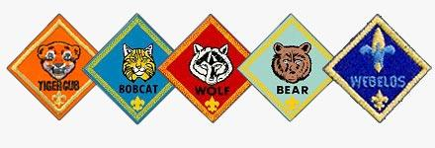
The Pack Committee

Position | Name | email | Phone
Cubmaster | David Thompson | opticalaoe@gmail.com | 770-880-6194
Asst. Cubmaster | Open
Committee Chair | Gina Sharp | beeamustang@gmail.com | 770-313-4795
Secretary | Open
Treasurer | Laura Paisner | laura.paisner@gmail.com | 678-468-9282
Advancements | Open
Fundraising | Allison Chamblee | allisonchamblee@gmail.com | 334-492-1677
Public Relations & Communication | Open
Outdoor Activities | Open
Membership & Registration | Open
ScoutParent Unit Coordinator | Open
Charter Organization Rep | Bonnie Knowlton | bjknowlton@bellsouth.net | 770-380-4786

Den Leadership Team

Rank / Den # | Position | Name | email | Phone
Lions – Den 4 | Boy Den Leader | Open
 | Girl Den Leader | Open
Tiger – Den 1 | Boy Den Leader | Tesfaye Birhanu | leykuntesfaye@gmail.com | 678-984-1317
Tiger – Den 2 | Girl Den Leader | Open
Wolf – Den 4 | Boy Den Leader | Jesse Joyner |  | 770-402-9179
Wolf – Den 2 | Girl Den Leader | Cham Lee | nychumnean@gmail.com | 770-757-7940
Bear – Den 3 | Boy Den Leader | Dana Walker |  | 770-940-2665
 | Asst. Den Leader | Gabriel Tormos | gabriel.tormos@gmail.com | 757-701-4690
Bear – Den 2 | Girl Den Leader | Monica Dixon | mncdxn@gmail.com | 678-973-3173
Webelo I – Den 2 | Boy Den Leader | Allison Chamblee | allisonchamblee@gmail.com | 334-492-1677
Webelo I – Den 1 | Girl Den Leader | Gina Sharp | beeamustang@gmail.com | 770-313-4795
Webelo II – Den 9 | Boy Den Leader | Laura Paisner | laura.paisner@gmail.com | 678-468-9282
Webelo II – Den 3 | Girl Den Leader | Marion Matiz |  | 470-606-1465
Table of Contents

Pack 100 Mission . . . . . . . . . . . . . . . . . . . . . . . . . . . . . . . . . . . 4

Cub Scouting and Your Family . . . . . . . . . . . . . . . . . . . . . . . 4

What is Cub Scouting? . . . . . . . . . . . . . . . . . . . . . . . . . . . . . . 5

Who Can Be a Cub Scout? . . . . . . . . . . . . . . . . . . . . . . . . . . . 7

Joining Pack 100 . . . . . . . . . . . . . . . . . . . . . . . . . . . . . . . . . . . . 9

Parent Responsibilities . . . . . . . . . . . . . . . . . . . . . . . . . . . . . . . 11

The Structure of Cub Scouting . . . . . . . . . . . . . . . . . . . . . . . . 12

The Pack 100 Cub Scout Program . . . . . . . . . . . . . . . . . . . . . . 14

Rules of Conduct . . . . . . . . . . . . . . . . . . . . . . . . . . . . . . . . . . . . 17

Safety Guidelines . . . . . . . . . . . . . . . . . . . . . . . . . . . . . . . . . . . . 18

Cub Scout Glossary . . . . . . . . . . . . . . . . . . . . . . . . . . . . . . . . . . 20

Pack 100 Mission

The leaders of Cub Scout Pack 100 are committed to providing a quality, year-round program of Cub Scouting activities. Special emphasis is placed on character development, outdoor activities, sports, citizenship, and family.

Cub Scouting and Your Family

Do you want your child to grow up to be self-reliant, dependable, and caring? Is it important to you that they learns traditional values such as honesty, trustworthiness, and respect for others and the environment? Are you looking for a program for your child that supports their development and your family? If you answered “yes” to any of these questions, then you should discover what Cub Scouting has to offer your child.

Pack 100 invites parents and their children to become part of one of America’s leading value-driven organizations. The Cub Scout program combines fun with educational opportunities and lifelong values. It helps parents to help their children strengthen character, develop good citizenship, and enhance both mental and physical fitness. The program also provides children with a positive peer group and the tools to shape their future.

In Cub Scouting, children learn ideals such as honesty, bravery, and respect. These values help them make constructive decisions throughout their lifetimes and give them the confidence they need to grow and develop. The unique aspect of Cub Scouting is that you, the family, join the program with your child. You will help them along the way.
What is Cub Scouting?

In 1930, the Boy Scouts of America launched a home- and neighborhood-based program for boys age nine to eleven. The program focused on nature, hobbies, games, preparation for Boy Scouts, and above all, character. While the Cub Scouting program has changed over the last 75 years, now admitting boys as young as six as Tiger Cubs, and grown from 5,102 boys and 243 Packs in 1930 to over 1.9 million boys in more than 53,000 Packs today, the focus of the program is still on preparing boys and girls to become better adults.

Cub Scouts is a home and neighborhood centered program for younger boys and girls. An essential element of the program is an emphasis on caring, nurturing relationships between children and their parents, adult leaders, and friends.

Cub Scouting is for boys and girls in kindergarten through fifth grades. Scouts are part of a Pack that is composed of many dens. Typically four to eight children are assigned to a den. Each Den has an adult Den Leader, Assistant Den Leader(s) and several parents who assist at the different activities. While most Dens meet semi weekly, the entire Pack meets together once a month. Your child will be placed in an age specific group and advance to a new rank each year whether he completes the program requirements or not.

Each badge (shown on pages 7&8) comes with a series of requirements that can be completed during the scout year, but only with family assistance; family assistance is essential! The Arrow of Light is Cub Scouting’s highest award. Not every Webelos Scout earns this award, only those who work hard. The requirements for each badge are clearly spelled out in the program handbook.

There are also many supplemental awards that can be earned each year by learning new skills or participating in additional activities. Prizes can be earned by participating in Scout-sponsored fundraising events. Thirty-seven different academic and sports belt loops and pins can be earned by learning more about each subject. Finally, various patches can be earned by attending different events throughout the year.

Scouts, families, leaders and chartered organizations all work together to achieve the ten purposes of Cub Scouting:
- To influence the development of character.
- To encourage spiritual growth.
- To help boys develop habits and attitudes of good citizenship.
- To encourage good sportsmanship and pride in growing strong in mind and body.
- To improve understanding within the family.
- To strengthen the ability of Scouts to get along and respect other people.
- To foster a sense of personal achievement in Scouts by helping them develop new interests and skills.
- To show Scouts how to be helpful and to do one’s best.
- To provide fun and exciting new things for boys and girls to do.
- To prepare boys to become Boy Scouts.

We achieve these purposes by teaching the ideals of Cub Scouting, which are represented by the Scout Oath, the Scout Law, and the Cub Scout Motto.

Scout Oath
On my honor, I will do my best,
to do my duty to God and my country,
and to obey the Scout Law;
To help other people at all times;
To keep myself Physically Strong,
Mentally Awake and Morally Straight.

Scout Law
A Scout is:
Trustworthy
Loyal
Helpful
Friendly
Courteous
Kind
Obedient
Cheerful
Thrifty
Brave
Clean, and
Reverent

Cub Scout Motto
Do your best!

Who Can Be a Cub Scout?

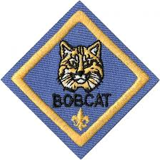
The Cub Scouting program is for boys and girls Kindergarten through fifth grade. The program is broken into ranks, and the children work to earn a specific rank each year in the Pack.

The Bobcat Badge must be earned first by all Scouts when they join the Pack. Although the boys can work on their rank requirements before earning the Bobcat, they cannot receive any recognition for the requirements until they have received their Bobcat. The Bobcat Badge demonstrates that the Cub Scout has learned the basic elements of being a Cub Scout.

The Tiger Cub Program was established for younger children – those six years old and in the first grade. It is based on shared leadership of child-adult teams, and it is a school-year-based program.

Every Tiger Cub has an adult partner. This is usually a parent or guardian but can be another relative or other adult approved by the child’s parent/guardian. In addition to the adult partners, each Tiger Cub den is assigned a Tiger Den Leader. The partners and den leader share the leadership of the Tiger Cub den, with each adult partner usually taking responsibility for one month’s meetings. Tiger Dens usually meet twice a month. Additionally, fun outings called Go See Its will be scheduled during the year.

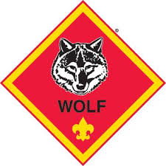
The Tiger Cub Badge is awarded to a Tiger Cub who has completed five achievements in each of three areas: den activity, family activity, and a Go See It. In addition, they can earn beads by working on the electives in the back of the book.

Scouts who have completed first grade or are 8 years old work towards the Wolf rank. To earn their Wolf badge, they must complete twelve achievements involving simple physical and mental skills. The Scouts meet as a den under the leadership of a Den Leader. A Wolf den leader is an adult volunteer who leads a Wolf den with the help of assistant den leaders and parents. After receiving the Wolf badge, Scouts can begin earning arrow points for electives they complete.

When a Scout has completed the second grade or is 9 years old, they begin working towards his Bear rank. There are 24 Bear achievements in four categories (God, Country, Family, and Self). The Cub Scout must complete twelve of these to earn the Bear badge. These requirements are somewhat more difficult and challenging than those for the Wolf rank. A Bear den leader is an adult volunteer who leads a Bear den, with the help of assistant den leaders and parents.
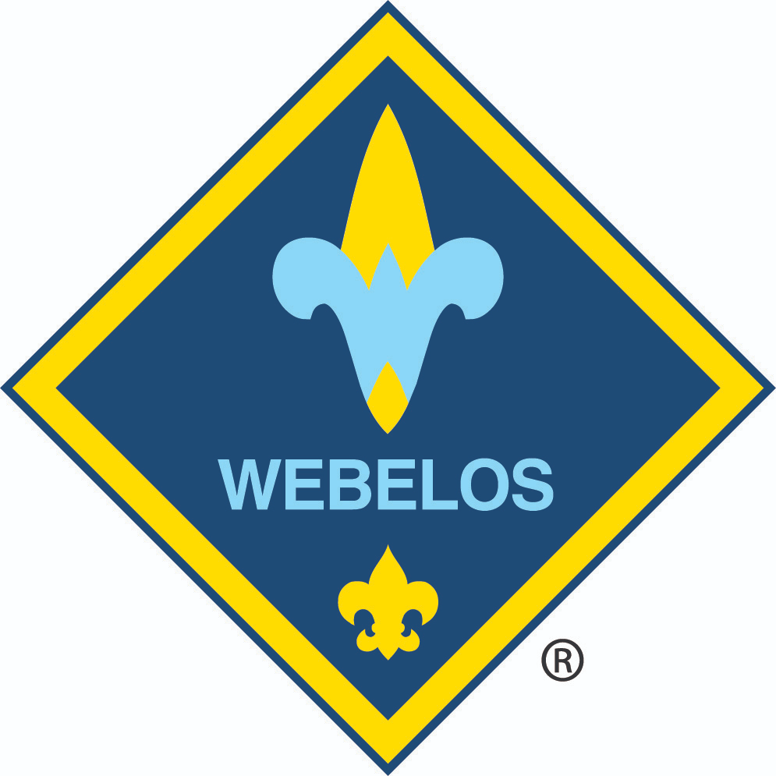

Webelos Scouts are boys and girls in the fourth and fifth grades or 10 years old. Webelos (pronounced WEE-bu-lows) has a special meaning for Cub Scouts. The word is made up from the first letters of these words, which remind Cub Scouts that they will someday be Boy Scouts: “WE’ll BE LOyal Scouts”. Webelos is also the name of the fourth badge of rank a Cub Scout can earn.

The Webelos program focuses on more challenging and independent activities and begins the transition to Boy Scouts. Webelos work on 20 activity pins in five groups (Physical Skills, Mental Skills, Community, Technology, and Outdoors).

Webelos Scouts who are advancing from a Webelos I den or who are joining Cub Scouts and are in the fifth grade will be assigned to a Webelos II den. The Webelos emblem and Arrow of Light emblem are taken from our American Indian heritage.
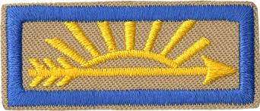

By the time the Scout begins the fifth grade, they should be ready to work on their Arrow of Light. This is the highest award in Cub Scouting, and is awarded to a Webelos Scout who completes additional requirements, including additional activity badges and interaction with a Boy Scout troop (such as join a hike). This is one of the few badges that can be carried over to the Boy Scout uniform. By the middle of fifth grade (sometime between December and February), the Webelos Scout will be ready to cross over into Boy Scouts and join a Boy Scout Troop.

Joining Pack 100

Any child in the kindergarten through fifth grades is welcome to join Pack 100. The child’s parent or legal guardian must fill out a Cub Scout application, which can be obtained from the Cubmaster or Pack Committee Chairman or at the Northeast Georgia Council offices.

Registration

The registration fee for joining Cub Scouts is $33 per year. This fee pays for registration with the Boy Scouts of America, unit insurance and basic leader training. The registration fee should be turned in to the Treasurer along with the Cub Scout application. Pack 100 also charges an annual Pack Dues fee of $60 per year, which helps to cover the Scout’s awards and advancements, supplies for Den and Pack meetings, and administrative costs to operate the Pack.

Uniforms

An essential component of Cub Scouting is the uniform. The uniform helps Cub Scouts identify more strongly with the group and gives them a place to proudly display their awards. To encourage this, the Pack requires Cub Scouts to wear an appropriate uniform to Scouting activities. Uniforms are divided into 2 classes; Field uniform (class A) and Activity uniform (class B). Specific activities will determine which class of uniform must be worn.

The Field uniform for Tiger, Wolf and Bear Cubs is an official blue Cub Scout shirt, nice blue jeans (no cutoffs or holes), the official belt, the official neckerchief, and a neckerchief slide of any type, plus patches for the World Scout Crest Emblem, Council, Pack number, den number, and rank insignia. Other uniform items, such as a cap, socks, or official pants, are optional. Official badges, awards, and patches may be added as they are earned.

Cub Scouts who are members of Webelos patrols wear the khaki (the same as Boy Scouts) Field uniform which includes an official tan shirt, nice blue jeans (no cutoffs or holes), the official belt, the official neckerchief, and a neckerchief slide of any type, plus patches for the world Scout Crest Emblem, Council, Pack number, patrol patch, and rank insignia. Second year Webelos are expected to wear the official pants as well. Other uniform items such as a cap or socks are optional. Khaki shirts are worn with blue shoulder loops. Official badges, awards, and patches may be added as they are earned.

The red patch vest is optional and is a good place to put all the patches and awards the Cub Scout earns that are not allowed on the uniform. It may be worn over the Field uniform.

Activity uniforms (class B) are simpler. Any T-shirt bearing an official Scout design (such as our Pack t-shirt or those awarded at scheduled Scout activities like Scout summer camp) may be worn as the Activity uniform. Activity uniforms are usually worn when the Field uniform might be damaged or unduly soiled.

Uniforms can be purchased at the Lawrenceville Scout Service Center at 203 Swanson Drive, Lawrenceville 30043. Their phone number is 770-962-2105, and their website is http://www.nega-bsa.org/shops/lawrenceville.shtml . Hours are 9:00am to 6:00 pm Monday through Thursday, 9:00 – 5:00 on Friday, and 10:00am to 2:00pm on Saturdays.

The Pack also has a limited supply of gently used uniforms (class A & B) available for those in need of specific assistance. Please see the Cubmaster for more details.

Other Needed Items

In addition to a uniform, you need to purchase a Handbook for your boy’s rank. Scouts in the first grade need a Tiger Cub Handbook, second-grade Scouts need a Wolf Handbook, third-grade Scouts need a Bear Handbook, and boys in the fourth or fifth grade need a Webelos Handbook. These handbooks can be purchased at the Scout Shop along with the uniform.

Scholarships

We strongly believe that financial difficulties should not prevent a scout from participating in any of our programs. Should fees or costs become an issue for your family, please contact the Pack Committee Chair or Treasurer. Scholarships are available, and all requests will remain confidential.

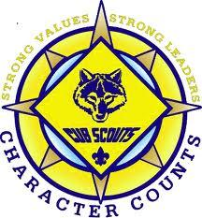

Parent Responsibilities

When joining Pack 100, each parent or adult family member agrees to support their child in the following ways:

- See that they has the proper uniform and handbook.
- Assist them in attending weekly Den meetings.
- Be present with your Scout at the monthly Pack meetings; these meetings are special for the Scouts and are designed to be meaningful for family members as well.
- Work with your child to complete the achievements for their rank award.
- Return information forms and permission slips as required.
- Support their Den Leader as a resource person or substitute as asked.
- Agree to serve in some leadership capacity as called upon.
- Provide input to the Den Leader or Pack leadership with regard to Den or Pack programming.
- Walk your scout in; come in to pick them up for each time we gather. Scouts should never be left without the parent bringing them in and making sure there are 2 Scout Leaders in the room the child is left in. The parents need to return to the room to pick their child up.
- Arrive on time for meetings; return on time to pick them up

We strongly encourage all parents to take Scouting’s Youth Protection Training to learn how to support the leaders in ensuring the personal safety of their children. This training is available at BSA’s online training website, www.my.Scouting.org. You do not need to be a registered adult member to create an account and take this online training. Please contact the Cubmaster or Committee Chair for more information.

Parent volunteers are always needed. The cost of registration for trained leaders is covered by the Pack for those who are interested in serving. If you’d like to help in any capacity, please contact the Cubmaster, Pack Committee Chairman, or your Scout’s Den Leader. All types of help are needed—driving on trips, helping to organize events, assisting in a Den Leader’s absence, etc. Remember, a Cub Scout Pack can not exist without volunteer leadership. Please do your part when asked.

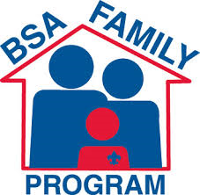

The Structure of Cub Scouting

Like every effective organization, Cub Scouting has a structure. Understanding this structure and how it works will increase your Scout’s enjoyment of the program and leave the parent far less confused.

Dens

A den is a group of up to ten children all of the same rank, with an ideal size of 4-8 children. Each den is led by a Den Leader and Assistant Den Leader. A Boy Scout, known as a Den Chief, may also work with your child’s den. Dens meet twice a month on Sundays from 2:30pm to 4:00pm during the school year.

Dens meet at Harmony Grove United Methodist Church.

Pack 100 has one or more dens for every rank of Cub Scouting. These are Tiger Cubs (first-graders), Wolves (second-graders), Bears (third-graders), and Webelos (separate dens for fourth- and fifth-graders).

Pack 100

The Pack consists of all of the dens and their families. Pack 100 meets monthly for Pack Meetings during the school year, generally on a Sunday in Berrier at Harmony Grove United Methodist Church from 2:30 pm to 4:00pm. Special pack events also occur occasionally throughout the year and may include activities such as the Pinewood Derby, the Blue & Gold Banquet, sports activities, or other pack outings.

The pack serves as the parent organization for the dens and provides direction, program support, leader training, and maintenance of the budget. The Pack is led by the Cubmaster and the Pack Committee Chair. The Cubmaster acts as the Master of Ceremonies at the monthly Pack meetings and other special activities. Several Assistant Cubmasters may also help with these events.

Pack Committee

The Pack Committee is made up of volunteer adults from the Pack who manage the Pack and its programs. The Pack Committee Chair runs the committee meetings and is the primary leader of the Pack. Along with the Cubmaster, the Pack Committee Chair leads the group in planning and organizing the Pack program. The Pack Committee also plans the Pack budget and maintains the Pack funds. The Pack Committee meets four to six times during the year.

Parents are encouraged to serve on the Pack committee and are welcome to attend committee meetings.

Chartered Organization

Every Cub Scout Pack is required to have a sponsor, known as the Chartered Organization. Pack 100 has been chartered by the Friendship Class of Harmony Grove United Methodist Church since 1964. The Chartered Organization Representative is a member of the Pack Committee and helps to ensure that the Pack is managed properly.

District and Council

Pack 100 is part of the Sweetwater District, which covers most of Gwinnett and Walton Counties. The Sweetwater District, along with six other districts, makes up the Northeast Georgia Council, which covers Northeast Georgia. The District provides support for all of the scouting programs (Cub Scouts, Boy Scouts, and Venturing), training for leaders, and runs various events such as Day Camp. The Council provides additional support for all scouting programs, operates Camp Rainey Mountain, Scoutland and Camp Rotary, and runs the Scout Shop (located in Lawrenceville).

The Pack 100 Cub Scout Program

Pack 100 runs a year-round program filled with activities. While we don’t expect every Scout to attend every function, we do encourage them (and their family) to be as active as possible. Scouts are expected to attend all den meetings, and both Scouts and their parents are expected to attend all Pack meetings. Parents are also encouraged to attend den meetings and all other events as well. Note that Tiger Cubs attend all functions with their adult partner.

To keep parents informed about events, Pack 100 uses a website called ScoutBook. On the Pack’s ScoutBook page, you can view the Pack calendar of events for the current program year, your Scout’s awards & advancement progress, as well as viewing and editing profile information (address, phone, email address, etc.) for you and your Scout.

Once your registration has been completed, you will be added to the Pack’s ScoutBook page. You will receive an email from ScoutBook inviting you to log on using the password provided so that you can activate your account. Please do so as soon as possible so that you can review the profile information we have for you and ensure it is correct.

Pack Meetings

The core of the Pack program is the monthly Pack Meeting. Each Pack Meeting includes activities centered around a monthly theme, and the Scouts may also focus on this theme in their Den Meetings. The Pack Meeting provides an opportunity to recognize the advancement and achievements of the Scouts, their parents, and their leaders. The Pack meeting also gives the Scouts a chance to demonstrate the skills they have learned and show off projects that they have completed in their dens.

Camping

Pack 100 offers several camping activities each year. These include Fall & Spring Family Camping, as well as an annual Pack Trip. In addition, several District & Council camping opportunities exist throughout the year such as Webelos Woods, Spring Fling, Summer Day Camp/Twilight Camp, and Summer Adventure Camps.

Fall & Spring Family Camping is held at a variety of locations and provides a weekend full of Cub Scout activities, including campfires, fishing, hiking, and crafts. Families camp together and are responsible for their own meal planning. The entire family is invited, including siblings.

Day Camp provides a four- or five-day program of scouting activities, including BB guns, archery, and athletics. The last day of Day Camp is usually Family Day, where parents and siblings are invited to join in the fun and discover what their boys have been doing during Day Camp. Our Pack has attended Day Camps in Lilburn for many years.

Adventure Camp is focused primarily on Webelos Scouts, but Bear Scouts are able to attend with a parent. Adventure Camp is held at Scoutland on Lake Lanier and lasts four days and three nights. Scouts participate in scouting activities such as swimming, BB guns, and archery and work on rank advancement, completing either Bear achievements or Webelos activities.

Back2Pack Picnic

The Scout year begins with the Back-2-Pack picnic in August. This is an opportunity for returning scouts and their parents to get together for fun, fellowship, and food! The Pack supplies hot dogs and condiments. Families are asked to help by bringing a side dish and beverage. Everyone has a great time. Parents fill out necessary paperwork and obtain schedules for the year. Children have fun. Siblings are welcomed!

Pinewood Derby

The Pinewood Derby is one of the most popular and memorable events in Cub Scouting. Pack 100 holds its Pinewood Derby in January. Scouts receive their kits in November or early December and work with their parent to create a car to race. We hold a Pinewood Derby Workshop to give the boys some help getting started. Scouts are expected to do as much of the work as possible by themselves with adult guidance. Tiger Cubs may only be able to help sand and paint their car, while Webelos should be able to do almost all of the work themselves. Scouts compete by rank in race and show categories, and the winners represent our Pack at the Council Pinewood Derby in April.

Blue & Gold Banquet

The Blue & Gold Banquet is Cub Scouting’s birthday party. Held each year in February, the Blue & Gold Banquet serves as the February Pack Meeting, and is a chance for the Pack to come together for an evening of celebration as we recognize the accomplishments of our Scouts. It is also the time of year when our Webelos II Scouts say good-bye to Cub Scouting and cross-over into the Boy Scout Troop of their choosing. This is a very special night for the Scouts and their families.

Summer Program

While there are no Den Meetings or Pack Meetings during the months of June, July, and August, the Pack does not shut down. In addition to the camping activities mentioned above, Pack 100 runs a full summertime program. Special activities and gatherings are planned, and boys are encouraged to remain active. Past activities have included picnics, hikes, a water park, trips to the airport or a state park, ice skating, and bowling. Scouts who participate in at least one activity in each of the summer months earn the Summertime Award.

Special Events

The Pack plans a variety of other special events throughout the year that help the Scouts with advancement, teach new skills, and provide an opportunity for a good time. These events may include going on hikes or tours, attending athletic events, or performing service projects.

Fundraising

There are two annual fund raising events that Cub Scouts participate in. As you might imagine, Pack and den fees do not cover the costs to operate the Scouting organization. There is a Popcorn sale where Cub Scouts take orders and collect funds for several types of popcorn. Additionally, in the spring, the Scouts will have an opportunity to earn money toward summer camp or other scouting needs by selling Camp Cards. Camp Cards are discount cards which include coupons and other discounts at a variety of local Lilburn business. Many of the coupons and discounts are reusable for a full 12 months, making them a great value.

Finally, Pack 100 is a supporter of the Friends of Scouting campaign. This annual campaign provides funds for the Northeast Georgia Council. None of your registration fee goes to the Northeast Georgia Council. Council funds come from two primary sources: popcorn sales by units in the Council and Friends of Scouting. Our Pack includes a Friends of Scouting drive at the annual Blue & Gold Banquet.

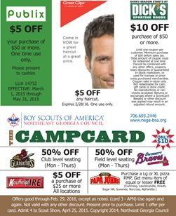

Rules of Conduct

Inappropriate Behavior

The goal of Pack 100's leaders is to have a safe, fun program for the Scouts and their families. The adult leaders have the right to intervene in any situation that they deem unsafe. If a Scout is unwilling to abide by the requirements of the adult leaders in charge, the leaders may require a parent to come get the Scout. Swearing, foul language and verbal abuse will not be tolerated.

Electronic Entertainment

Pack 100 does not allow the use of electronic entertainment (hand held games, iPods, cell phones, etc.) at meetings, scout-sponsored functions, or scout outings. Scouts using such items will be asked to stop, and if they do not comply, the adult leader may confiscate the item until the end of the event, at which point it will be returned to the Scout.

Electronic devices such as two-way radios, radios used to check weather reports, or other devices used to ensure the safety of the Scouts, parents, and leaders are allowed.

Camping Guidelines

Pack 100 strives to ensure that several outings each year include family camping. The scout and his entire family are encouraged to attend. The Boy Scouts of America have established guidelines for its members’ participation in camping activities.

A Cub Scout may participate in overnight camping when supervised by his parent or legal guardian. If a parent cannot attend, the boy’s family must make arrangements for another adult relative to be a substitute for a parent at the campout. It is essential that each Scout be under the supervision of an adult. Cub Scouts are limited to boy-parent excursions or program-managed family camping designed for the entire family.

When staying in tents, no youth will stay in the tent of an adult other than his or her parent or guardian. Webelos Scouts at certain approved outings (such as Adventure Camp) may stay in a tent with other children of the same gender without a parent, but still may not stay in the tent of an adult that is not his parent or guardian.

Other Policies

Scouts are expected to follow leadership of the Pack at all times.

Scouts should use the Buddy System at all times (at least 2 boys or girls together at all times.) This includes going to restrooms or to see your Mom in another room.

When the scout sign is up, all Scouts, leaders and adults are expected to become quiet and return the sign. No talking can be done with the sign up. Leaders, this includes you!! You can’t hold up the sign and tell the children that the sign is up. You are disobeying the rule we expect the children to follow. All scouts are expected to show proper respect to everyone. This includes other scouts, leaders, and parents.

Safety Guidelines

Use of Knives by Cub Scouts

To earn the right to carry a pocketknife at Cub Scout functions, Scouts must be in the third grade and have earned the Whittling Chip by completing the Shavings and Chips (Achievement 19) in the Bear Cub Scout Book. Please do not give your Scout a knife until they meet these requirements. Pack 100 encourages this award, as we feel it teaches respect for safety and personal property.

In return for the privilege of carrying a pocketknife at Cub Scout functions only, the Scout must understand the rules for safe use of a pocketknife and handle his pocketknife with care. Failure to follow the guidelines will result in suspension of their carrying privilege. If a Scout has a knife in his possession, they must be able to produce his Whittling Chip upon request of an adult leader. If the Scout is unable to produce their card, but has earned it, the knife will be forfeited until the end of the activity or meeting. BSA guidelines provide that the knife must be a folding knife with a blade shorter than the palm of the Scout’s hand.

Guide to Safe Scouting Extract

The following key items are extracted from A Unit Leader’s Guide for Current Policies and Procedures to Safe Activities (ISBN 0-8395-4416-2, © 1998 Boy Scouts of America). Leaders should have access to this document for additional safety topics not covered in this extract (swimming, boating, climbing, etc.). These are national policies enforced by the adult leaders of the Pack, and violation of these policies by a Scout or his parent may result in the removal of the Scout from the Pack. Repeated violations by members of a Pack can result in the revocation of the Pack Charter by the Boy Scouts of America. For additional information, refer to the online BSA document Guide to Safe Scouting at http://www.scouting.org/pubs/gss/toc.html.

Drug, Alcohol, and Tobacco Use and Abuse
The Boy Scouts of America prohibits the use of alcoholic beverages and controlled substances at encampments or activities on property owned and/or operated by the Boy Scouts of America, or at any activity involving participation of youth members.

Adult leaders should support the attitude that young adults are better off without tobacco and may prohibit the use of tobacco products at any BSA activity involving youth participants. All Scouting functions, meetings, and activities should be conducted on a smoke-free basis, with smoking areas located away from all youth participants.

Guidelines for Safely Using Chemical Stoves and Lanterns
Use compressed or liquid-gas stoves or lanterns with knowledgeable adult supervision only and in Scout facilities only where and when permitted. Never fuel a stove, heater, or lantern inside; always do this outdoors. Never fuel, ignite, or operate a stove, heater, or lantern in a tent. Do not leave a lighted stove or lantern unattended.

Flammability Warning
No tent material is completely fireproof. The most important safeguard is to keep flames away from tent materials. For this reason, the following safety precautions are emphasized:
- Only flashlights and electric lanterns are permitted in tents. No flames in tents.
- Never use liquid-fuel stoves, heaters, lanterns, matches, and other flame sources in or near tents.
- Do not pitch tents near an open fire.
- Only use battery-operated devices in tents.

Fireworks
The Boy Scouts of America prohibits the securing, use, and display of fireworks in conjunction with programs and activities except where the fireworks display is conducted under the auspices of a certified or licensed fireworks control expert. Guns, Firearms, and Archery The Boy Scouts of America adheres to its long-standing policy of teaching its youth and adult members the safe, responsible, intelligent handling, care, and use of firearms, airguns, and BB guns in planned, carefully managed, and supervised programs.

Shooting sports
Gun-shooting sports are not an approved part of the Cub Scout program except at council-approved Cub Scout camps. At camp, Cub Scouts may have an opportunity to take part in a BB gun (rifle) safety and marksmanship program under the direction of a trained and certified BB-gun range officer. Cub Scouts are not permitted to use any other type of handgun or firearm. Except for law enforcement officers required to carry firearms within their jurisdiction, firearms shall not be brought on camping, hiking, backpacking, or other Scouting activities. Archery and BB gun shooting are restricted to day camps, Cub Scout/Webelos Scout resident camps, council-managed family camping programs, or to council activities where there are properly trained supervisors and all standards for BSA shooting sports are enforced. Archery and BB gun shooting are not to be done at the Pack level. These programs are designed to emphasize safety and marksmanship development under the direction of trained range officers using nationally approved instructional methods.

Transportation

Seat belts are required for all occupants. All drivers must have a valid driver’s license that has not been suspended or revoked for any reason. Passenger cars or station wagons may be used for transporting passengers, but passengers should not ride on the rear deck of station wagons. Trucks may not be used for transporting passengers except in the cab. All vehicles must be covered by automobile liability insurance with limits that meet or exceed requirements of the state in which the vehicle is licensed. Do not exceed the speed limit.

If a vehicle to be used is designed to carry more than 15 persons, including the driver, the driver must have a commercial driver’s license. An adult leader must be in charge and accompany the group. The driver must be currently licensed and at least 18 years of age.

Cub Scout Glossary

Cub Scouting has a language all its own. Below are the definitions of many of the terms you will encounter in Cub Scouting.

Achievement
To earn the rank badge, Wolf and Bear Scouts must complete achievements found in their Handbook.

Activity Badge
There are 20 activity badges that a Webelos Scout can earn. These are divided into five areas: Physical, Mental, Technology, Outdoor, and Community. A pin is awarded for completion of each activity badge.

Adult Partner
The adult member of a Tiger Cub team.

Advancements
Advancements in Cub Scout rank are presented at each Pack meeting and include Tiger, Bobcat, Wolf, Bear, Webelos, and Arrow of Light Badges.

Akela
A leader; this may be the Cubmaster, parents, religious leaders, Den Leaders, or any other person providing leadership.

Arrow of Light
This is the highest award a Scout can earn in Cub Scouting, and is also the only (non-religious) award from Cub Scouts that can be worn on a Boy Scout uniform.

Arrow Points
Arrow points are awarded to Wolf and Bear Scouts for completing electives beyond the achievements required to earn their rank badge. A Gold Arrow Point is awarded for the first ten electives completed; a Silver Arrow Point is awarded for each successive ten electives completed.
Bear Scout
These are generally third-grade Cub Scouts who work on activities in four areas: God, Country, Family, and Self. Of the 24 possible achievements, they must complete a prescribed amount from each area for a total of 12.

Blue & Gold Banquet
A birthday dinner for Scouting held by Cub Scout Packs in February to celebrate the founding of the Boy Scouts of America in 1910 and Cub Scouting in 1930.

Bobcat
Every Scout who joins Cub Scouts must first earn the Bobcat badge. In doing this, he learns the seven basic tenets of Cub Scouting: the Promise, the Law of the Pack, the sign, the handshake, the motto, the salute, and what Webelos means.

Boy Scout
A Boy Scout is between the ages of 11 and 18 and belongs to a Troop. They advances through the ranks of Tenderfoot, Second Class, First Class, Star, Life, and Eagle.

Boy Scouts of America
The Boy Scouts of America is a nationally-chartered organization that encompasses Cub Scouts, Boy Scouts, Explorer Units, Varsity Scouts, and Venturing Crews.

Chartered Organization
This is the organization that charters a unit and approves the leaders. The Chartered Organization Representative serves on the Pack Committee. Pack 100 is chartered by the Friendship Class for Harmony Grove United Methodist Church.

Committee
This is the group of adult volunteers who run the Pack. Any interested adult is welcome to attend Committee meetings.

Committee Chair
The primary leader of the Pack. The Committee Chair works with the Pack Committee, Cubmaster, and Chartered Organization Representative to plan the Pack program, recruit leaders, and maintain the budget.

Council
The Council is an organization of professional (paid) Scouters that oversees all Cub Scout Packs, Boy Scout Troops, and other units in the area. Pack 100 is part of the Northeast Georgia Council.

Crossover
When Webelos Scouts become Boy Scouts.

Cub Scout
A Cub Scout is a member of the Boy Scouts of America in the first through fifth grade (or ages 6 to 11).

Cubmaster
The Cubmaster is sometimes known as the unit leader of the Pack. The Cubmaster runs the Pack meetings, advises Den Leaders, and works with the Pack Committee to plan and run the Pack program.

Den
The Den is a group of Cub Scouts who meet at regular intervals. Ideally, a Den consists of four to eight Scouts who are all working towards the same rank.

Den Chief
A Boy Scout, usually of First Class rank or higher, who serves as an assistant leader in a Den.

Den Leader
The adult volunteer who is in charge of planning and running den meetings.

Den Meeting
Individual Den Meetings are held for each rank level of Cub Scouts. These usually occur at regular intervals, such as weekly or bi-weekly. Wolf and Bear dens work on fun projects, crafts, skits, or some of their achievements. Webelos dens use this time to work on the various activity badges

Denner
A Cub Scout or Webelos Scout elected by his peers to help the den chief and den leader.

District
Each Council is divided into a number of Districts. Pack 100 is part of the Sweetwater District. The District Executive oversees the activities of all units in the District.

Handbook
Each level of Scouting has its own Handbook. The Handbook is essential for your Scout, as it spells out the requirements for advancement as well as providing a place to record their completion.

Pack
All of the Cub Scouts in our Dens and their families make up the Pack. The Pack usually meets once every month during the school year.

Pinewood Derby
A Pack activity that involves making and racing model cars on a track. Pack 100 usually holds its Pinewood Derby in February.

Rank Badges
The rank badges for Cub Scouts are, in order, Bobcat, Tiger, Wolf, Bear, Webelos, and Arrow of Light.

Scouter
A registered adult member of the Boy Scouts of America who serves in a volunteer or professional capacity.

Summertime Award
To earn the National Summertime Pack Award, a Cub Scout Pack must plan and conduct three Pack activities—one each in June, July, and August. Cub Scouts who participate in all three activities may wear the National Summertime Pack Award pin on their uniform. Pack 100 generally offers at least two activities in each summer month in order to provide boys and their families plenty of opportunities for fun and to qualify for the National Summertime Pack Award.

Tiger Cub
Tiger Cubs are first-graders who, with an adult partner, participate in five achievements, each consisting of a Family Activity, a Den Activity, and a Go See It.

Tiger Partner
The adult partner of a Tiger Cub, usually a family member. Tiger Partners accompany their Tiger Cubs to all Scouting events and activities.

12 Core Values
The 12 Core Values of Cub Scouting are citizenship, compassion, cooperation, courage, faith, health and fitness, honesty, perseverance,
positive attitude, resourcefulness, respect, and responsibility.

Uniform
The uniform is the prescribed clothing for any and all official Cub Scout events and activities. Pack 100 has both Class A and Class B uniforms (see the Uniforms section).

Unit
Each individually chartered Pack, Troop, Post, Lodge, or Crew in the Boy Scouts of America is a unit.

Webelos
Webelos means WE’ll BE LOyal Scouts. Webelos is both the singular and plural form.

Webelos Scout
These are fourth- and fifth-grade Cub Scouts who work on up to 20 activity badges in the den setting. These activities are designed to prepare the Scouts for the merit badge methodology used in Boy Scouts.

Wolf Cub
These are generally second-grade Cub Scouts who work on 12 achievements, mostly in the home setting. Arrow points are awarded for work done on a multitude of electives.

