Mom and Me Weekend 2015 Event Application

Scout Name: _____________________________________________Pack #:____________

Mom’s Name: ________________________________________________________________

Email: _________________________________________________________________________

Phone #: ______________________________________________________________________

Additional Campers:

Name: _________________________________________________________ Age: _________

Name: _________________________________________________________ Age: _________

Event T-Shirt Order. YM-AL $8 per shirt, AXL-2X $10 per shirt
Size | YM | YL | AS | AM |  | AL | AXL |  | A2X
Quantity
This is a rain or shine event. Cancellation requests must be received in the council office no later than 5:00 pm Monday, September 21, 2015.
Deadline for registration is 23 Sept 2015. Deadline for ordering t-shirts is 7 Sept 2015.  BSA Medical Form Parts A & B required for event.  Return/Mail forms to:  Mom and Me  CCBSA  1025 Sam Rittenburg Blvd  Charleston, SC 20407  Register Online at:  http://www.coastalcarolinabsa.org/event/cub-mom-and-me/1742414 |  |  |  |  | PAYMENT
 |  |  |  |  | Event Fee $30 Per Person (includes lunch and dinner)
T-Shirt
$8 or $10 per shirt
 |  |  |  |  | Total
Mom and Me Weekend 2015
September 26-27, 2015
Camp Ho Non Wah
2609 Boy Scout Rd
Wadmalaw Island, SC 29487
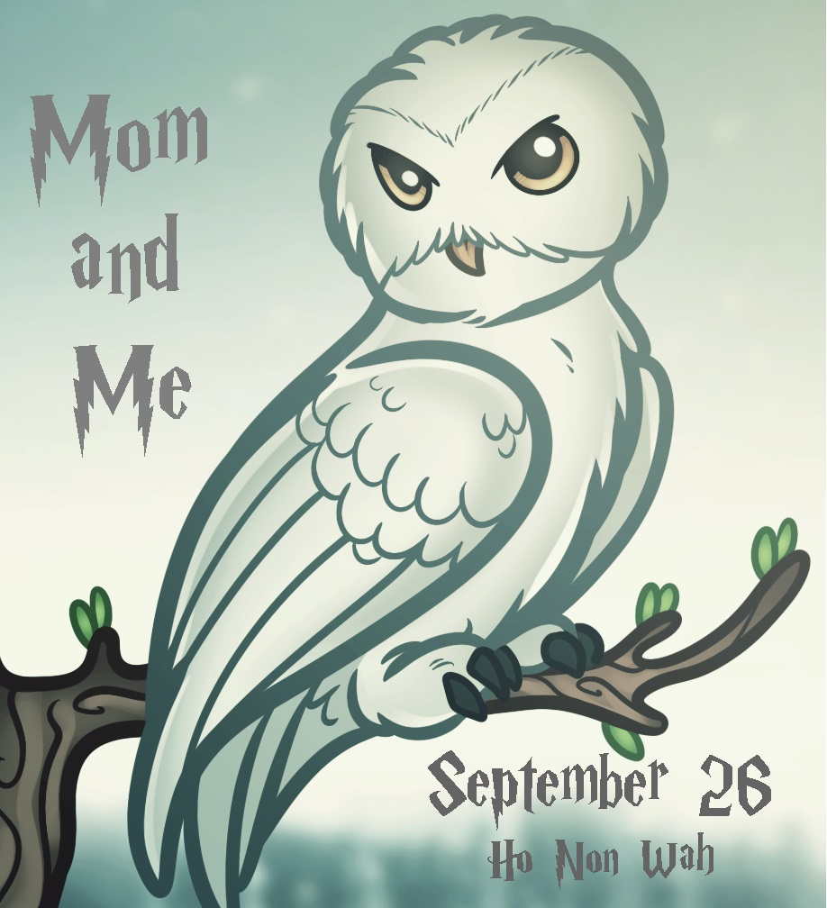
Planned Events
Archery
Canoes
Science and Potions
Arts and Crafts
Care of Magical Creatures
Wizarding Sports and Games
And more!

